PLAG-Introduction and Literature Review

*by* Lavish Garg

**Submission date:** 17-May-2023 08:50PM (UTC+0530)

**Submission ID:** 2095509837

**File name:** Introduction_and_Literature_Review.docx (296.06K)

**Word count:** 2680

**Character count:** 14670

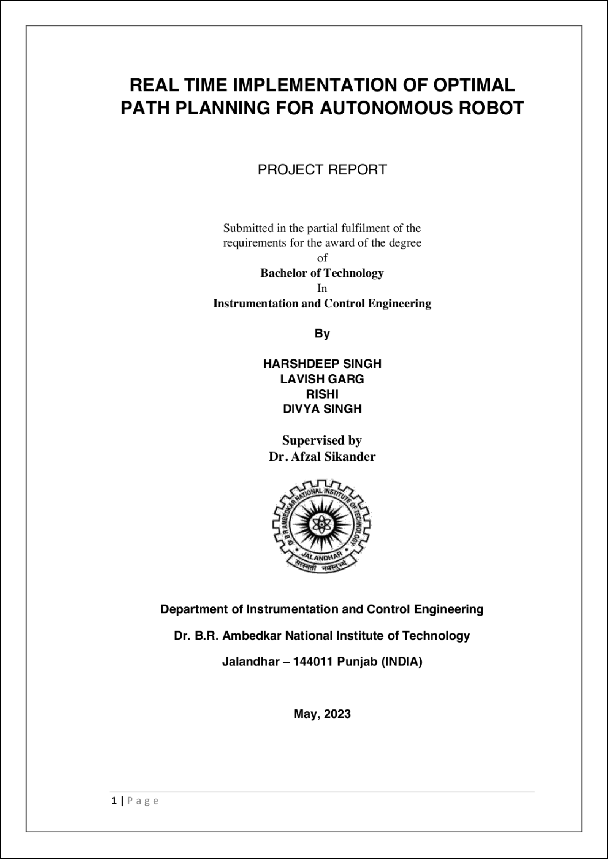

6

1

7

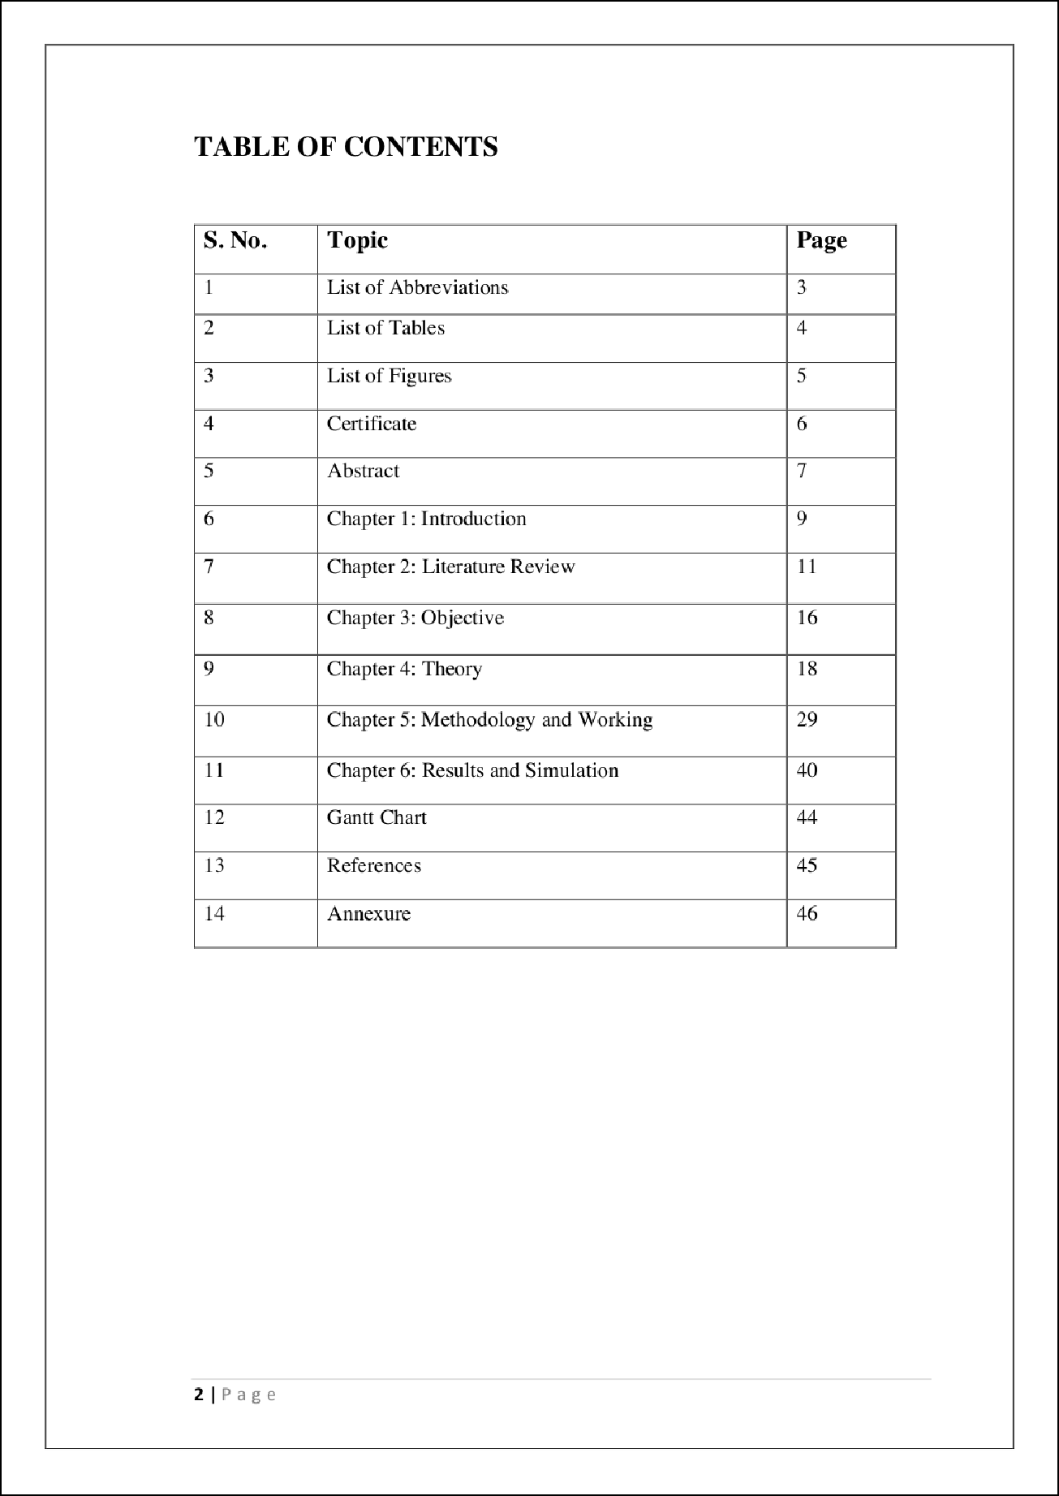

1

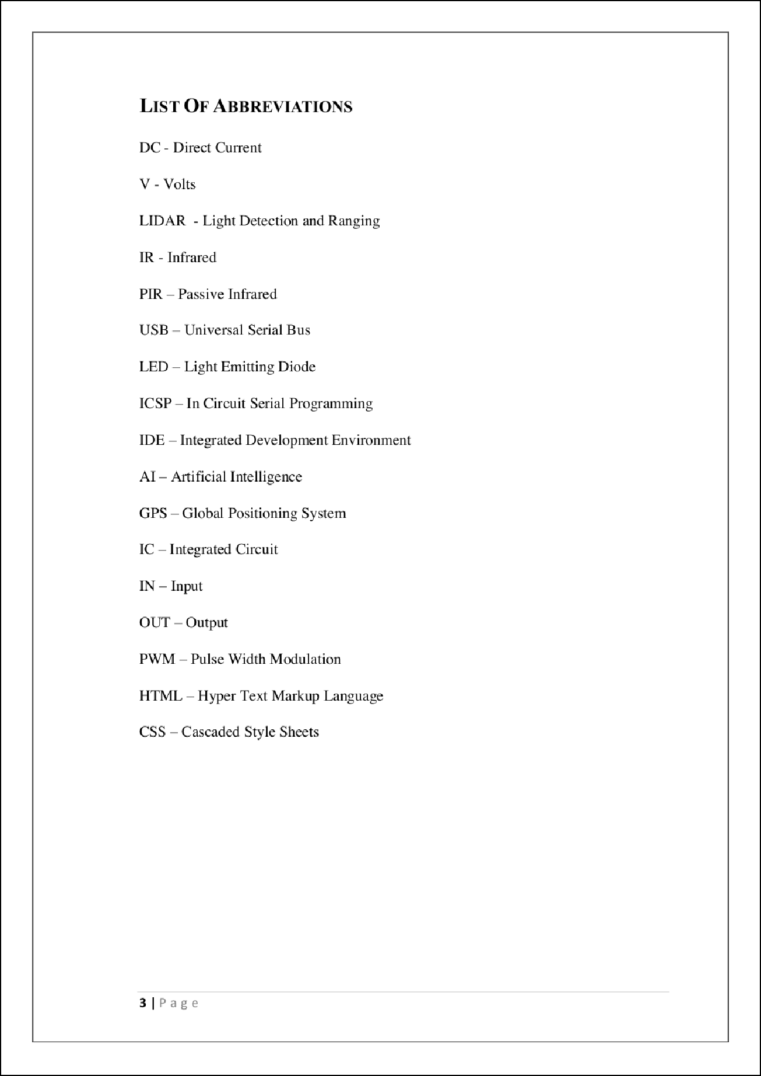

16

14

15



9

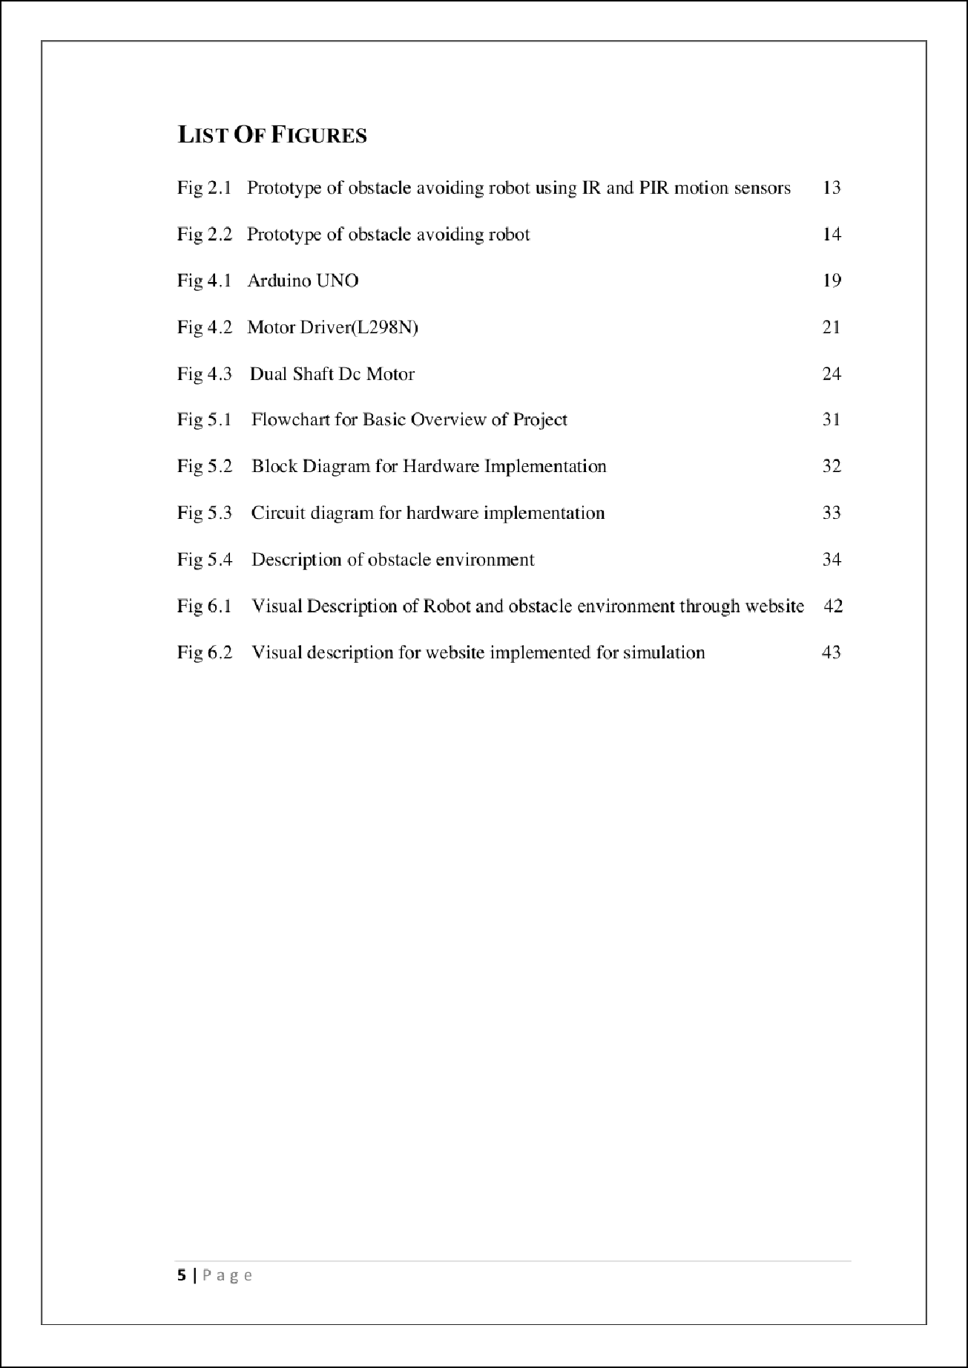

9

2

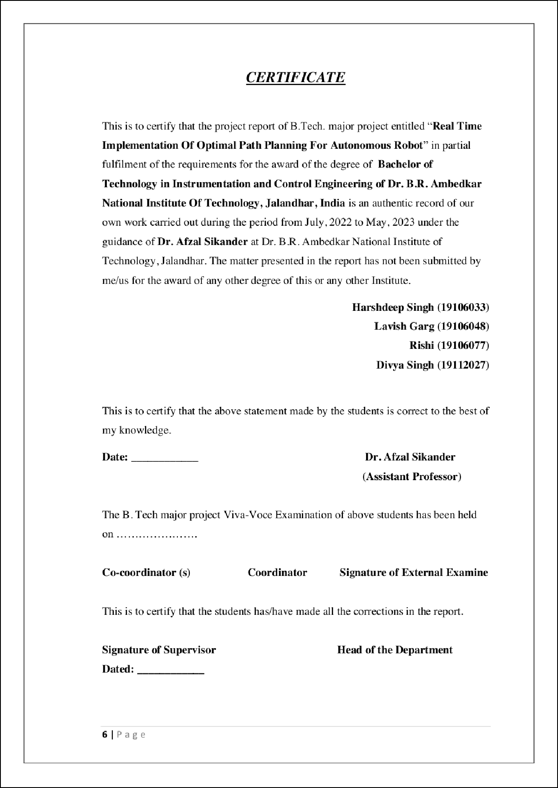

12

1

1

1

1

1

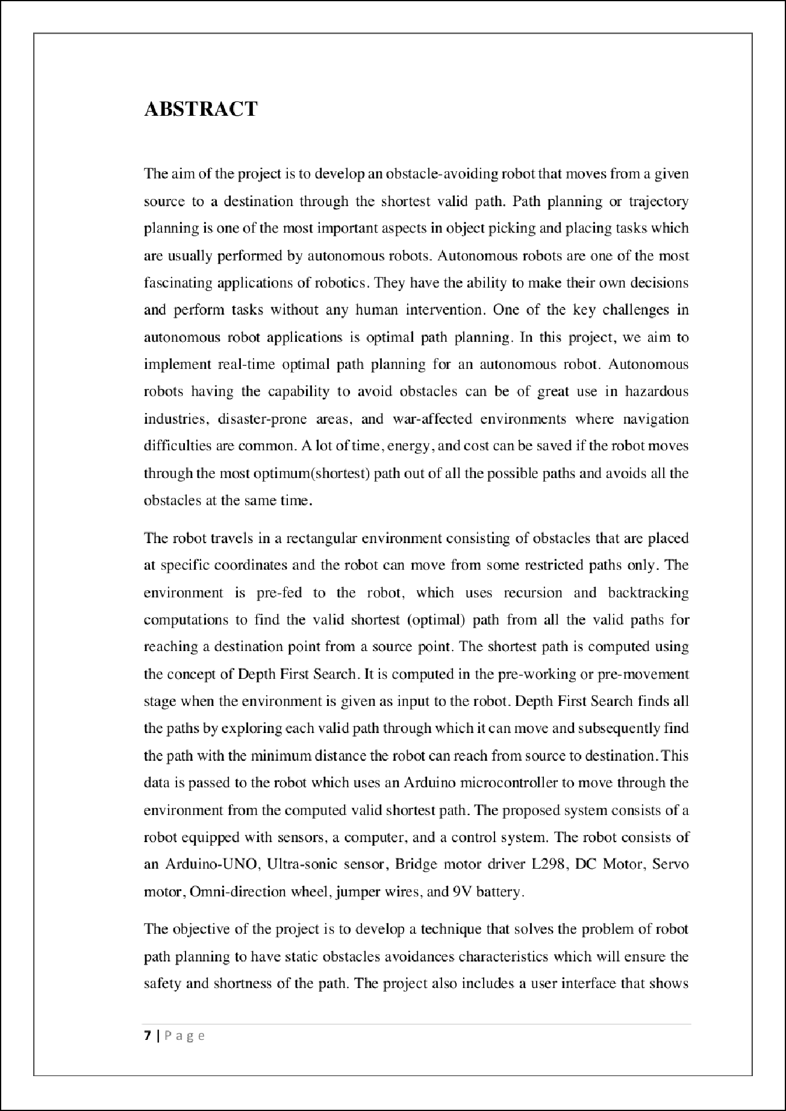

5

10

5

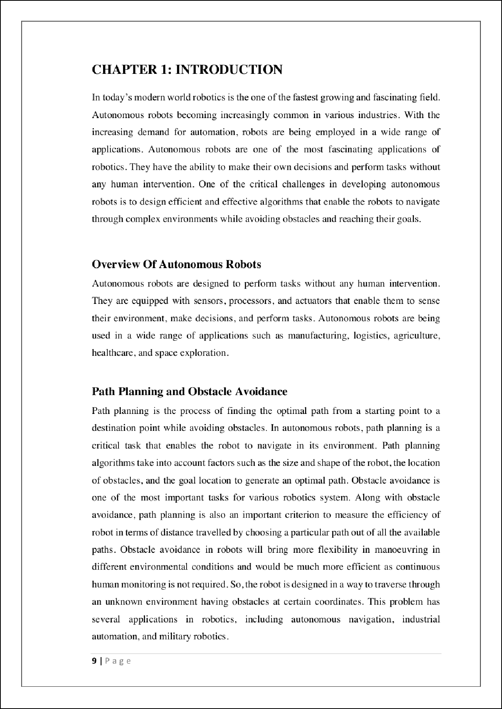

17

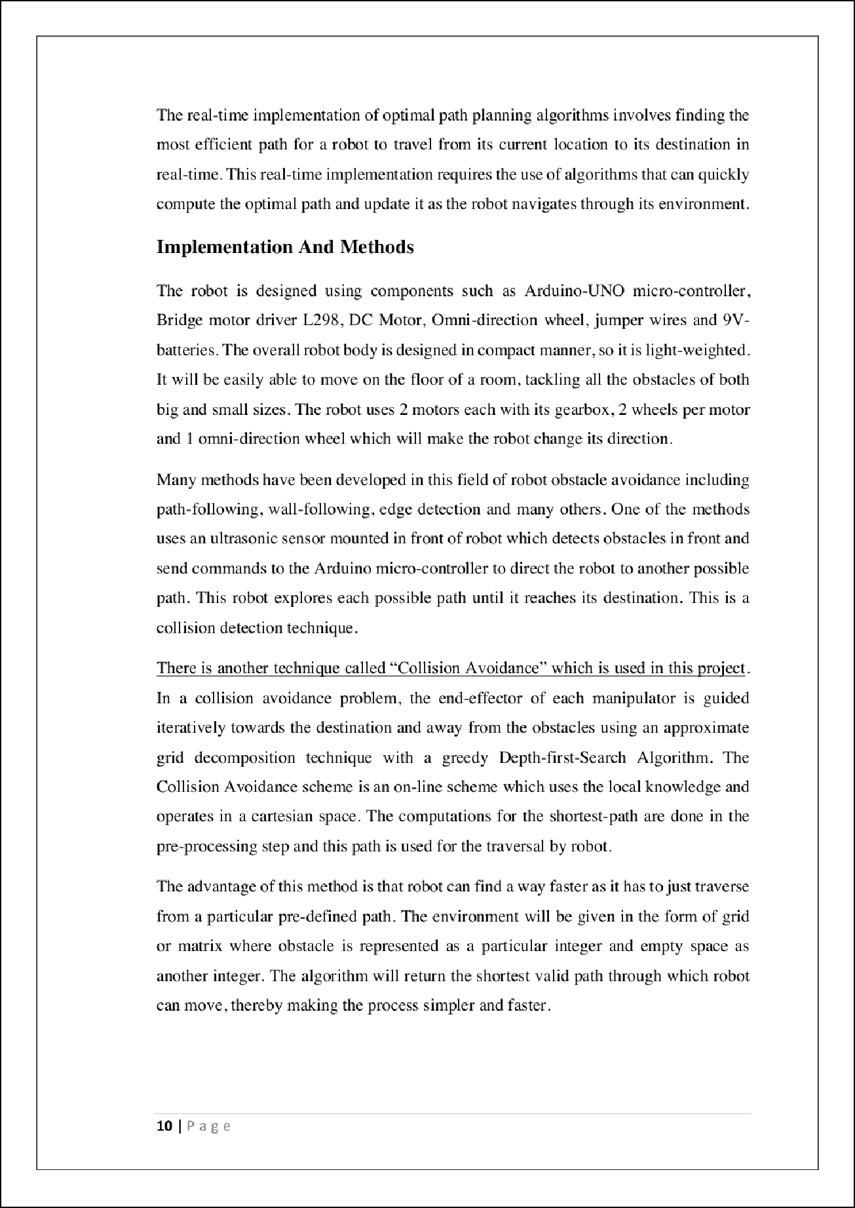

3

3

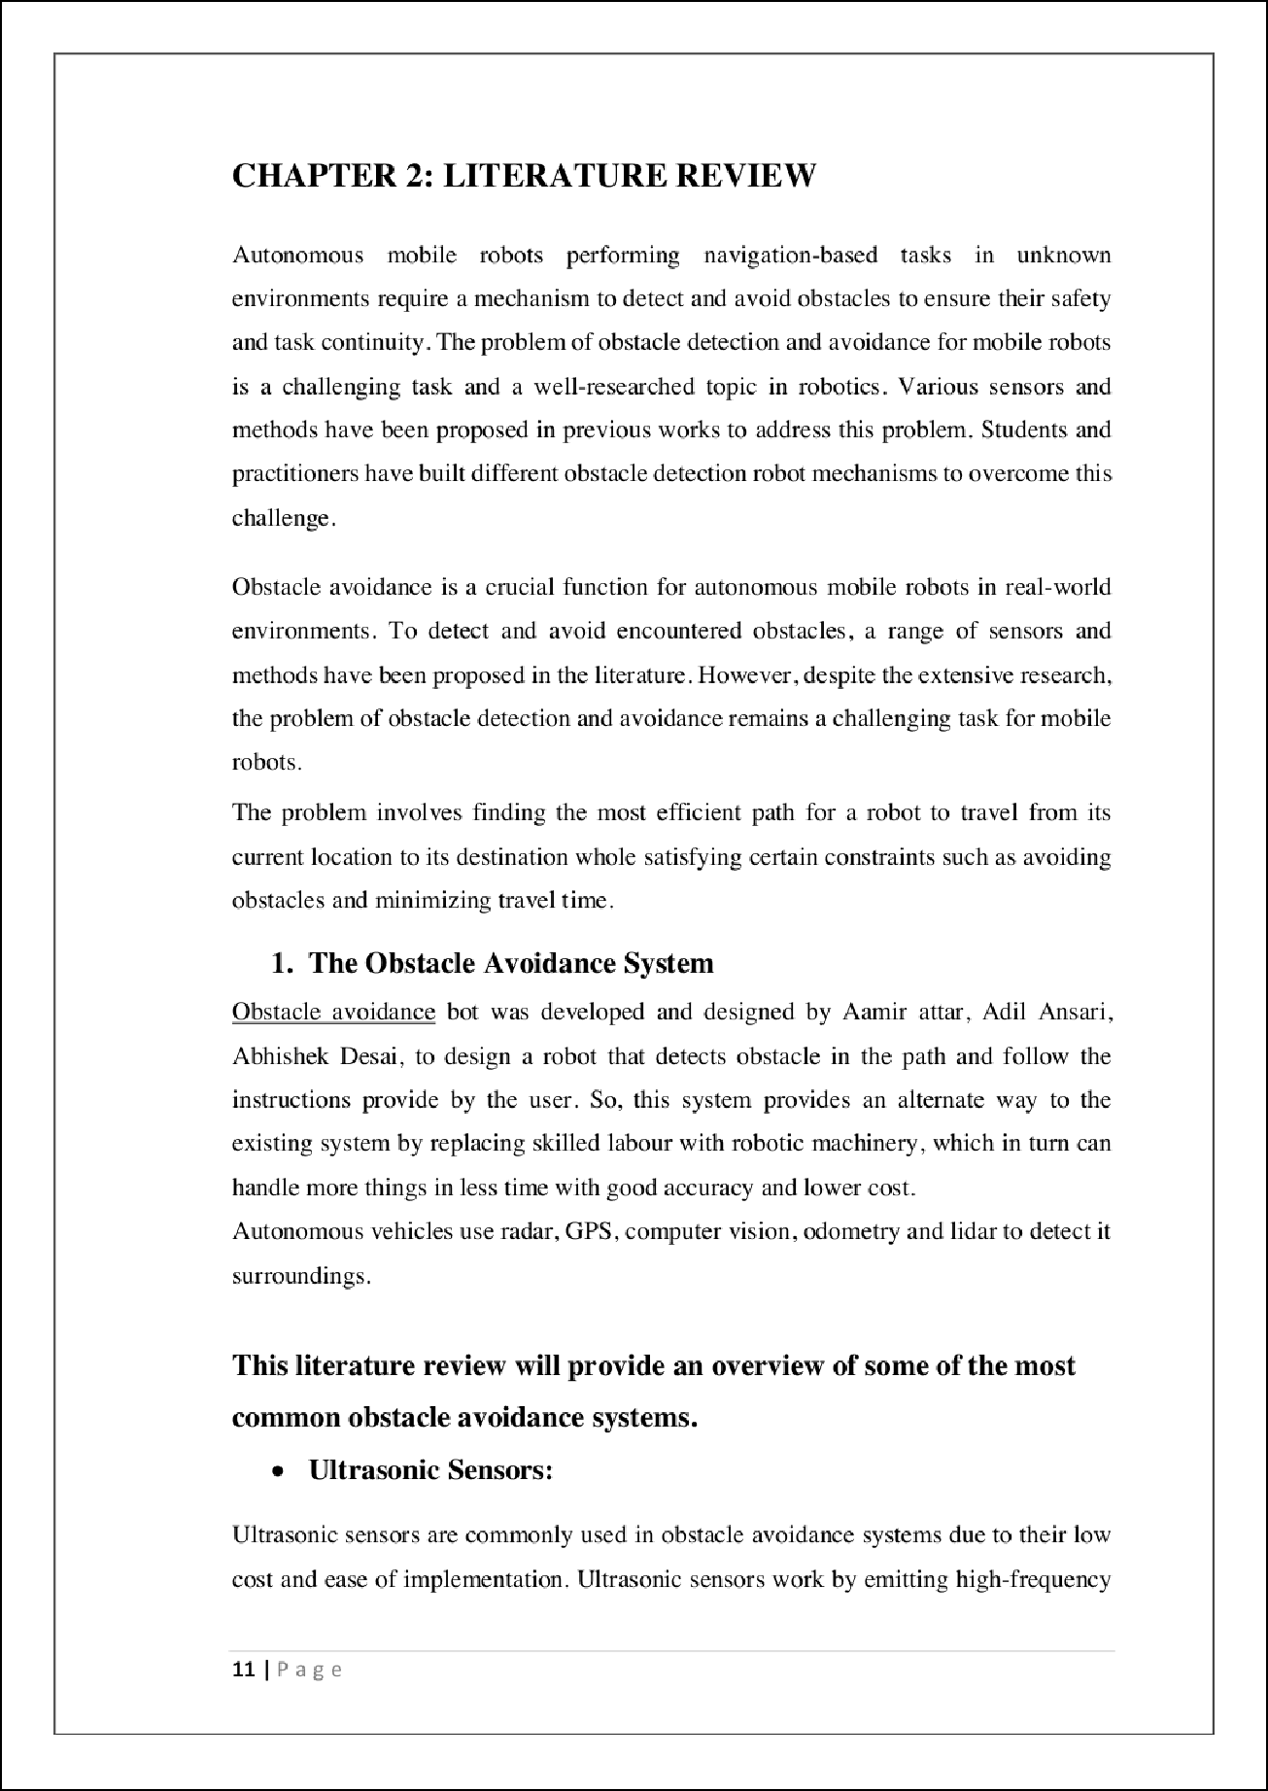

4

2

13

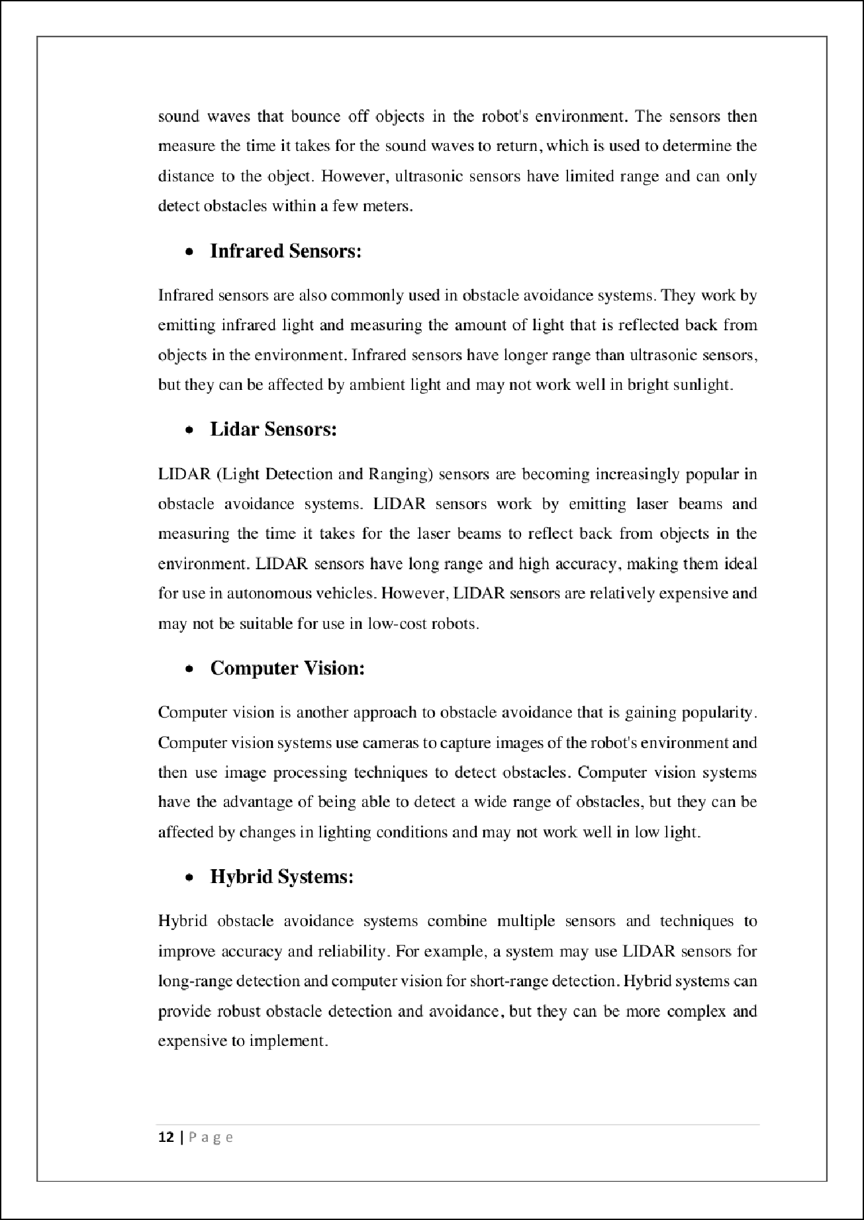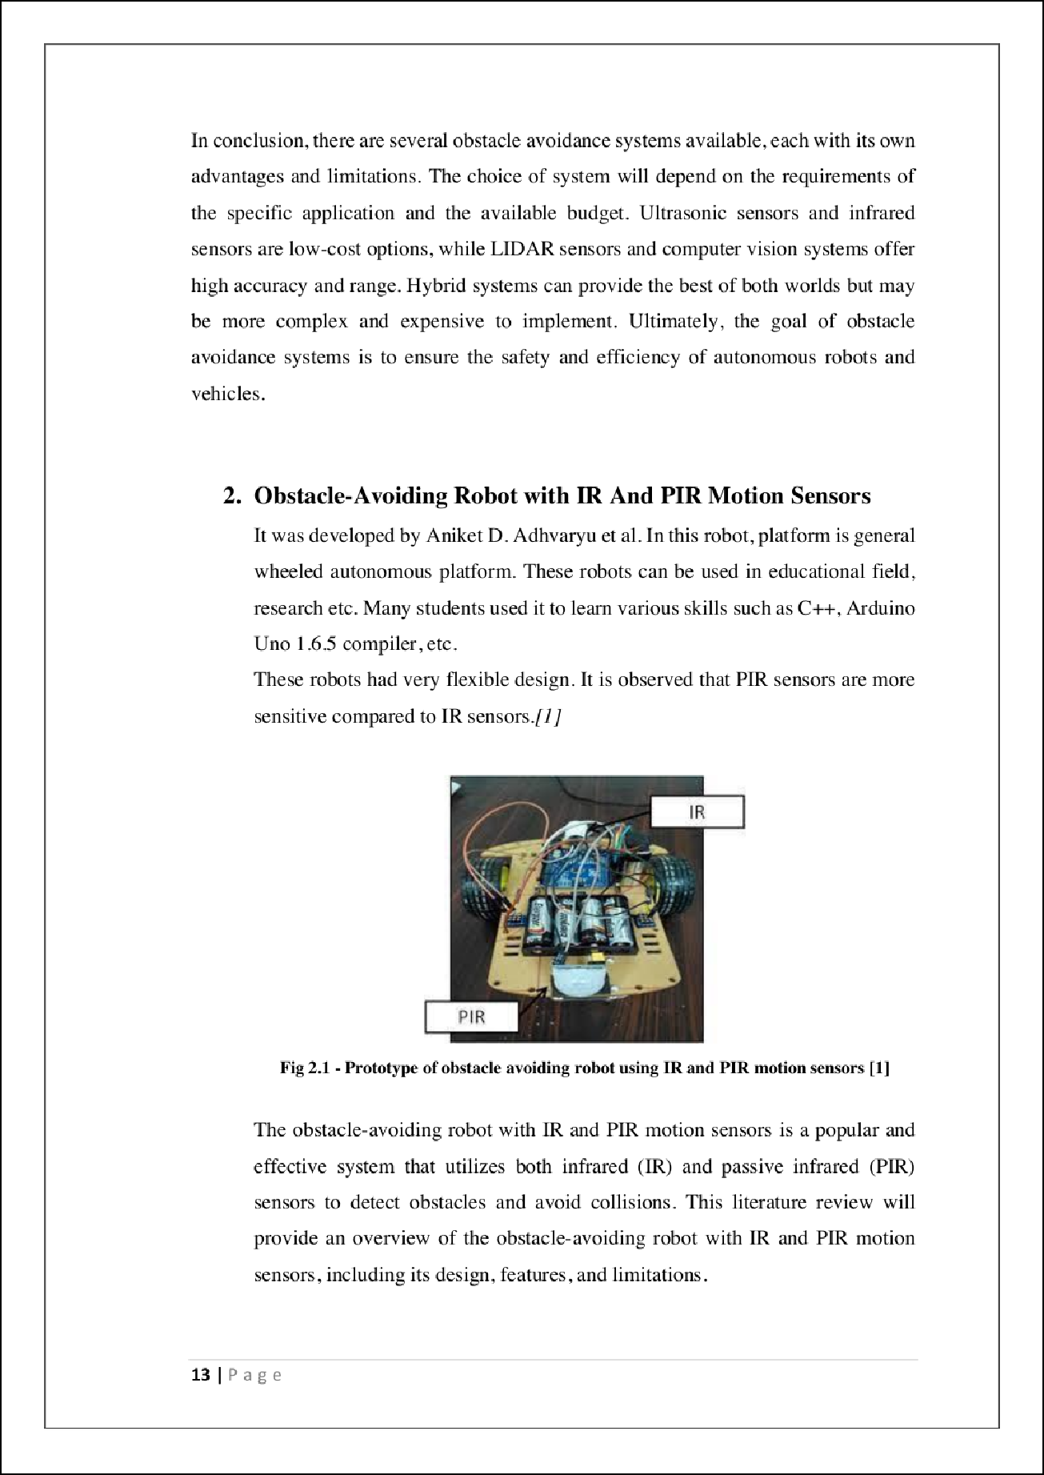

5

8 2

8

2

2

2

2

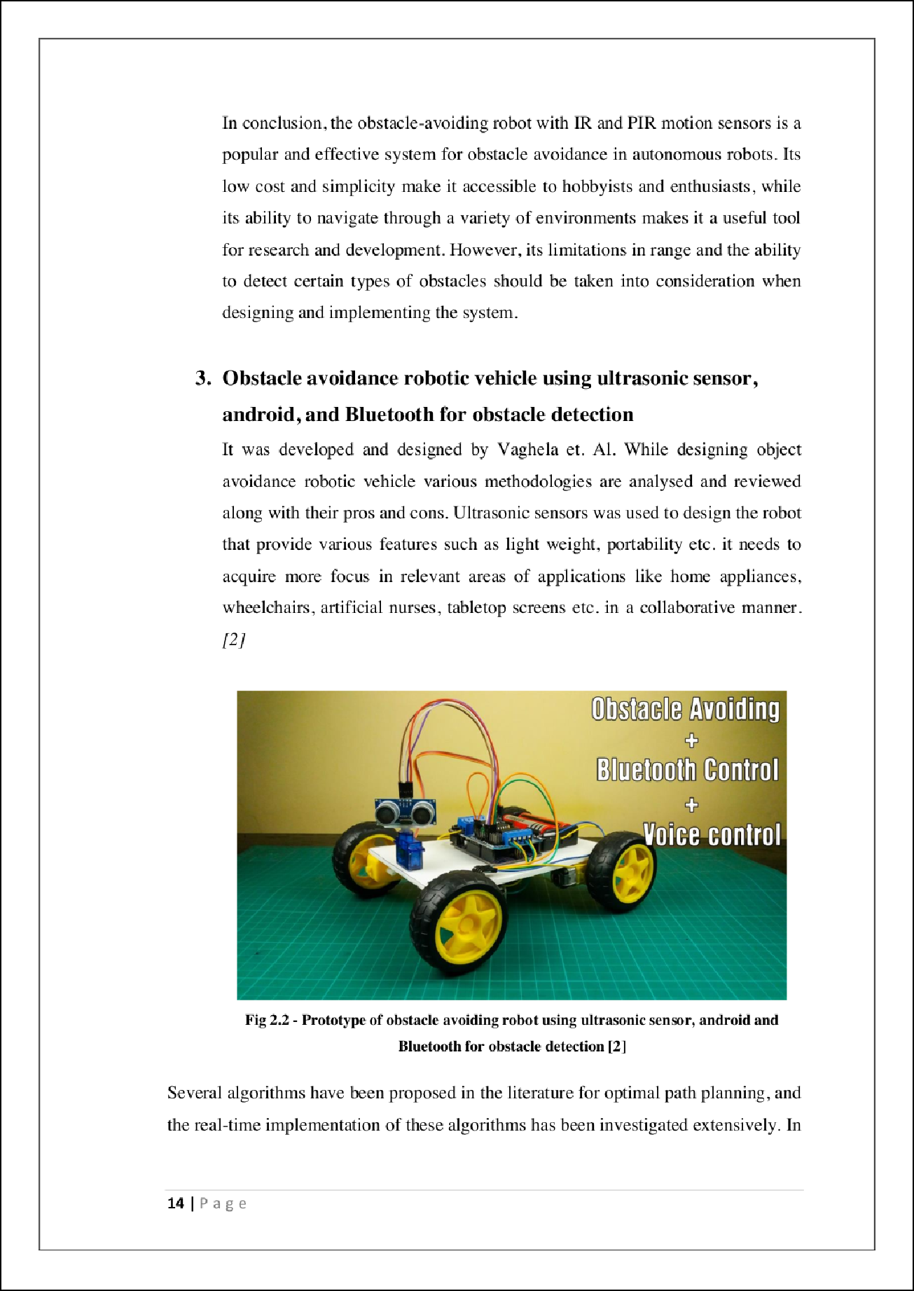

2

2

4

11



PLAG-Introduction and Literature Review

19

ORIGINALITY REPORT

%

SIMILARITY INDEX

16%

INTERNET SOURCES

10%

PUBLICATIONS

%

STUDENT PAPERS

PRIMARY SOURCES

[www.coursehero.com](http://www.coursehero.com/)

Internet Source %

1

6

4

[www.ijert.org](http://www.ijert.org/)

Internet Source %

2

2%

3 Gill, . "OVERVIEW", World Scientiﬁc Series in Robotics and Intelligent Systems, 1998.

Publication

1

ajec.smartsociety.org

Internet Source %

4

1

[www.science.gov](http://www.science.gov/)

Internet Source %

5

1

ethesis.nitrkl.ac.in

Internet Source %

6

1

louisdl.louislibraries.org

Internet Source %

7

1%

8 Bhoomika S., Peram Varshitha, Bhoomika M.S., Michelle David, Adithya T.G., Pavithra G., Sindhu Sree M., T.C.Manjunath. "Patient monitoring smart robot for biomedical

9

10

11

12

13

14

15

16

17

engineering applications", international journal of engineering technology and management sciences, 2022

Publication

Douglas Jenkinson. "Outbreak in the Village", Springer Science and Business Media LLC, 2020

Publication

iarjset.com

Internet Source

dokumen.pub

Internet Source

nirmauni.ac.in

Internet Source

[www.electroduino.com](http://www.electroduino.com/)

Internet Source

eprints.utm.my

Internet Source

[www.praktiker.at](http://www.praktiker.at/)

Internet Source

dspace.daﬀodilvarsity.edu.bd:8080

Internet Source

futureenergysp.com

Internet Source

<1%

<1%

<1%

<1%

<1%

<1%

<1%

<1%

<1%

Exclude quotes Oﬀ Exclude bibliography On

Exclude matches Oﬀ